Global Framework Playbook
V 1.0


Table of contents
Using the Global Framework for the Supply of Technology Products and Services 4
1. Contents of the Global Framework document package 4
1.1 Overview 4
1.2 Folder structure and document details 4
2. Types of agreements 8
2.1 A framework agreement 8
2.2 Focused Frameworks 10
2.3 Standalone agreements 11
3. Creating a legally binding agreement using the documents provided 11
3.1 Localising the documents 11
3.2 Creating specific types of agreement 12
3.2.1. Network services agreement 12

Creating the schedules 13
1. Framework Agreement schedules 13
1.1 Overview 13
1.2 Worked examples 13
1.2.1. Policies and standards schedule 13
1.2.2. Special Terms schedule 14
2. Schedules to the Call Off Form 16

Additional and optional clauses 17
Available deliverables and catalogue 17
Catalogue Deliverables 17
Excluded deliverables 18
Indemnity for transferring personnel 18
IP approaches 18
Termination for change of control 20

Design style guide 21
1. Images 21
1.1 Overview 21
1.2 Editing diagrams 21
1.3 Adding diagrams to Word files 22
2. Word styles 23

Part 1

Using the Global Framework for the Supply of Technology Products and Services

Contents of the Global Framework document package

1.1 Overview
The Global Framework document package comprises the following documents:



Framework Agreement
Call Off Agreement
CALL OFF GENERAL
TERMS
ST
HARDWARE
CALL OFF FORM
FRAMEWORK
APPOINTMENT
TERMS
SCHEDULE
SPECIAL
TERMS
SCHEDULE
CALL OFF GENERAL
TERMS
SCHEDULE
POLICIES
AND
STANDARDS
SCHEDULE
GOVERN-
ANCE OF
THE FW
SCHEDULE
FRAME-
WORK
PRICES
SCHEDULE
FRAMEWORK
DELIVER-ABLES
SCHEDULE
BIDDING
& ORDERING
PROCESS
SCHEDULE
CALL OFF FORM
TEMPLATE
A. Guidance & resources
ST
CLOUD SERVICES
ST
SOFTWARE
DEVELOP-
MENT
ST
SOFTWARE
MAINTENANCE
& SUPPORT
ST
SOFTWARE
LICENCE
ST
PROFES-SIONAL
SERVICES

Special Terms

Framework Agreement Schedules
These schedules need to be completed by partner government. Guidance on completing the schedules is available in the Playbook and in the Schedules themselves.

Play-
book
Images
master files
B. Global Framework document kit

1.2 Folder structure and document details
The folder ‘Global Framework document kit’ is organized in two main sub-folders. The first folder contains the documents needed to build a Framework Agreement; the second folder contains the documents needed to build a Call Off Agreement for the provision of actual products or services.

Sub-folder 1 – Framework Agreement documents
Framework Appointment Terms | This document, executed between a government Department (e.g., government central purchasing agency) and a Supplier, creates a Framework Agreement to allow individual government Customers (e.g., cities, regions, departments, …) to purchase technology products and services from the Supplier.  The Schedules listed below are attached to the Framework Appointment Terms and, together, they make up the Framework Agreement.
Framework Schedules
Framework Schedule 1 – Framework Deliverables | ➔ The document provided is a rough outline of the topics to be covered in the schedule. A partner government will need to draft its full version in accordance with their particular needs.  This document should provide government’s specifications for various categories of technology products and services and should define how Suppliers need to make available their product/service descriptions.
Framework Schedule 2 – Framework Prices | ➔ The document provided is a rough outline of the topics to be covered in the schedule. A partner government will need to draft its full version.  This document should describe the pricing mechanisms and the rates to be used in calculating prices at Call Off Agreement level.
Framework Schedule 3 – Governance of the Framework Agreement | ➔ The document provided is a rough outline of the topics to be covered in the schedule. A partner government will need to draft its full version.  This document should define the governance structure for the Framework Agreement and how Supplier will coordinate with the relevant government department.
Framework Schedule 4 – Policies and Standards | ➔ The document provided is a rough outline of the topics to be covered in the schedule. A partner government will need to draft its full version.  This document should contain all the specific policies and standards that an appointed government Supplier needs to comply with (e.g., requirements on data protection, security, anti-bribery, corporate social responsibility, etc.)
Framework Schedule 5 – Bidding and Ordering Process | ➔ The document provided is a rough outline of the topics to be covered in the schedule. A partner government will need to draft its full version. It should describe how Customers can order Supplier’s technology products and services (direct award procedure) or require selected Suppliers to further define their solution and its pricing (further competition procedure).
Framework Schedule 6 – Call Off General Terms | This document contains the general terms and conditions applicable to the provision of any technology products or services under a Call Off Agreement.
Framework Schedule 7 – Special Terms | This document collects all the special terms that may apply to the provision of specific technology products or services under a Call Off Agreement. Depending on the deliverables ordered, a Call Off Agreement will later on incorporate at least one set of the Special Terms listed below:  Special Terms - Hardware  Special Terms - Cloud Services (these will include software-as-a-service, platform-as-a-service, and infrastructure-as-a-service)  Special Terms - Software Licence  Special Terms - Software Development  Special Terms - Software Maintenance and Support  Special Terms - Professional Services
Framework Schedule 8 – Call Off Form template | This document is a template of the Call Off Form that will be used to create a Call Off Agreement between Supplier and a specific Customer.

Sub-folder 2 – Call Off Agreement documents
Call Off Form | This document, filled in and executed between a government Customer (e.g., a city, a region …) and a Supplier, creates a Call Off Agreement for the provision of specific technology products or services.
Call Off General Terms | This document contains the general terms that will apply to the provision of any technology products or services under a Call Off Agreement.
Special Terms - Hardware | This document contains special terms that will apply under a Call Off Agreement where Supplier provides hardware to a Customer.
Special Terms – Cloud Services | This document contains special terms that will apply under a Call Off Agreement where Supplier provides cloud services to a Customer.
Special Terms – Software Licence | This document contains special terms that will apply under a Call Off Agreement where Supplier licenses software to a Customer.
Special Terms – Software Development | This document contains special terms that will apply under a Call Off Agreement where Supplier provides software development services to a Customer.
Special Terms – Software Maintenance and Support | This document contains special terms that will apply under a Call Off Agreement where Supplier provides software maintenance and support services to a Customer.
Special Terms – Professional Services | This document contains special terms that will apply under a Call Off Agreement where Supplier provides professional services to a Customer.

With these documents, it is possible to build different types of agreements, such as:
- The Framework Agreement + Call Off Agreement
- A focused Framework Agreement + Call Off Agreement (e.g., when the framework is limited to a narrow category of supply, for example, cloud services only)
- Standalone agreements focusing on a transaction or series of transactions with one Supplier.

Types of agreements

2.1 A framework agreement
The agreements envisaged by the Global Framework are comprised of two key components:
          - A framework agreement under which a lead governmental department contracts with the relevant Supplier to appoint it as a potential supplier of types of deliverables. The deliverables will not be purchased under the framework agreement but will be the subject of separate call off agreements. The Framework Agreement will comprise several documents to include the Framework Appointment Terms, the Call Off General Terms, and various schedules. The full list of documents is in section 1.5 of the Framework Appointment Terms.
          - Separate call off agreements that other government departments can enter into with a relevant supplier for the purchase of specific deliverables.
All Call Off Agreements will incorporate by reference the Call Off General Terms. Depending on the deliverables ordered, they will also incorporate at least one set of Special Terms.
The picture on the next page shows you how the parts fit together.


Framework Agreement
Documents marked in grey form part of the Framework Agreement, but will only apply in practice later on in the context of a Call Off Agreement.
Call Off Agreement
CALL OFF GENERAL
TERMS
APPLICABLE
SPECIAL
TERMS
CALL OFF FORM
FRAMEWORK
APPOINTMENT
TERMS
POLICIES
AND
STANDARDS
ALL
SPECIAL
TERMS
CALL OFF GENERAL
TERMS
POLICIES
AND
STANDARDS
FRAME-
WORK
GOVERN-
ANCE
FRAME-
WORK
PRICES
FRAME-
WORK
DELIVER-
ABLES

OTHER SCHEDULES
BIDDING
& ORDERING
PROCESS
CALL OFF FORM
TEMPLATE
Policies and Standards
need to apply also to
the relationship between Supplier and a specific Customer.
Between Supplier and government Department
(e.g. government central purchasing agency)
Between Supplier and a
specific Customer
(e.g. a city, a region, …)

2.2 Focused Frameworks
The Framework Agreement can also be used to create smaller frameworks i.e., it could conceivably be used as a standalone global framework for suppliers offering only Cloud Services or Software and/or Hardware. In such circumstances, the relevant government department should only include the appropriate Special Terms as part of the framework. See the examples below.

Cloud Services Framework Agreement
Documents marked in grey form part of the Framework Agreement, but will only apply in practice later on in the context of a Call Off Agreement.
Cloud Services
Call Off Agreement
CALL OFF GENERAL
TERMS*
CLOUD SERVICES
SPECIAL
TERMS*
CLOUD SERVICES
CALL OFF FORM
CLOUD SERVICES
FRAMEWORK
APPOINTMENT
TERMS
POLICIES
AND
STANDARDS
CLOUD SERVICES
SPECIAL
TERMS*
CALL OFF GENERAL
TERMS*
POLICIES
AND
STANDARDS
FRAME-
WORK
GOVERN-
ANCE
FRAME-
WORK
PRICES
FRAME-
WORK
DELIVER-
ABLES

OTHER SCHEDULES
BIDDING
& ORDERING
PROCESS
CALL OFF FORM
TEMPLATE
Policies and Standards
need to apply also to
the relationship between Supplier and a specific Customer.
Between Supplier and government Department
(e.g. government central purchasing agency)
Between Supplier and a
specific Customer
(e.g. a city, a region, …)
EXAMPLE: creating a Framework focused on cloud services
* Consider merging the contents of the Call Off General Terms and Special Terms – Cloud Services in just one “Terms” document suitable for the focused framework at hand.

2.3 Standalone agreements
If you wish, with a few changes, you could use the Call Off General Terms and Special Terms without the need for a framework agreement (for example, for a one-off deal with a supplier).
To use the documents in this manner, remember to search the Call Off General Terms for references to the “Framework Agreement” and change the references to, for example, “Schedule [x] – Policies and Standards of the Framework Agreement” to refer to a schedule of the Agreement (which will be based on the Call Off Form).


Standalone agreement
CALL OFF GENERAL
TERMS
APPLICABLE SPECIAL
TERMS
AGREEMENT
(BASED ON CALL OFF FORM)
POLICIES
AND
STANDARDS

OTHER SCHEDULES
Between Supplier and a specific Customer (e.g. a city, a region, …)

3. Creating a legally binding agreement using the documents provided

3.1 Localising the documents
The documents that comprise the Global Framework need some preparatory work before they are “match ready” for use. Please consider the following steps:
- review the Framework Appointment Terms, the Call Off General Terms, all Special Terms, and the Call Off Form template, especially the parts highlighted in blue and marked in square brackets as [Note to drafter], and make sure that the documents as a whole are customised for local law and your needs.
- review the example optional and additional clauses in Part 3 of the Playbook and consider whether they should be included,
- complete the schedules to the Framework Agreement (see the notes in Part 2 of this Playbook on what to include), and
- consider whether you wish to include all of the Special Terms in the bid package for the Framework Agreement. You may wish to hold back on including these as they are likely to complicate and lengthen the process to signature. It may be better to only include relevant Special Terms at the Call Off Agreement stage.

3.2 Creating specific types of agreement

3.2.1 Network services agreement
Network services agreements cover many different transaction types and, therefore, we have not included “standard” Special Terms for network services.
Network services agreements can, however, be built by mixing and matching relevant Special Terms as needed:
- Special Terms – Software Licence
- Special Terms – Hardware
- Special Terms – Cloud Services (e.g., if Customer is just buying access to a system)
These Special Terms may need to be amended to reflect the deal specifics.
Moreover, the following basic fields need to be added to the Call Off Form under section 2. Deliverables to make it suitable to capture key aspects of network services agreements.

 Network services
3.1 | Solution description | - [add description]
3.2 | Support services | - [add description]
3.3 | Service levels | - [add description]
3.4 | Treatment of assets | - [add details]
3.5 | Transformation plan and milestones | - [add details]

Part 2

Creating the schedules

Framework Agreement schedules

1.1 Overview
The contents of the schedules provided in this Global Framework package are rough outlines of what should be included in the Framework Agreement schedules. Partner governments will need to draft their own schedules.
The provided schedule templates contain hints and basic guidance to help you understand what issues to cover and how to make these documents work together as parts of your localised Framework Agreement.
The suggested schedules to include are:
          - Framework Deliverables
          - Framework Prices
          - Governance of the Framework Agreement
          - Policies and Standards
          - Bidding and Ordering Process
          - Call Off General Terms
          - Special Terms
          - Call Off Form Template
More schedules (or attachments under any of the schedules) can be added to this list as necessary to localise the Framework Agreement.

1.2 Worked examples
In the next sections, we will discuss how to organize two schedules in particular, Special Terms and Policies and Standards, which need to contain several documents as attachments.

1.2.1 Policies and Standards schedule
This schedule should include all the policies that the Supplier will have to comply with to be part of the Framework Agreement. Many of these policies will also need to be incorporated by reference in Call Off Agreements.
Examples of policies and standards to be addressed are (this is not an exhaustive list):
a. security policies
        - data privacy policies or legislation
          - compliance with the European Union General Data Protection Regulation or other local data privacy legislation
          - compliance with other local mandatory laws or other policies
        - policies relating to corporate social responsibility
        - anti-bribery policies
        - insurance requirements
        - etc.
Partner governments should consider creating a webpage through which all policies and standards could be made available for download by suppliers. This may be much more efficient than including huge amounts of extra documentation as part of the Framework Agreement. In addition to shortening the Framework Agreement this approach has the added advantage of ensuring that suppliers are accessing the most up to date policies. See the schedule template “Policies and Standards” for details on how to communicate this to suppliers.
As an alternative, the required policies and standards can be enclosed as attachments to the Policies and Standards schedule.


Link to webpage
Include as attachments
POLICY 1
POLICY 2
POLICY 3
POLICY 4
POLICY 5
POLICY 6
SCHEDULE
“POLICIES AND STANDARDS”
SCHEDULE
“POLICIES AND STANDARDS”
<Link>
View or
download
POLICIES AND STANDARDS

OR

1.2.2 Special Terms schedule
This schedule should include the Special Terms that will be used in conjunction with Call Off Agreements. As discussed above, you may decide that you do not want to make these available to suppliers at the Framework Agreement level. We list the Special Terms again here for ease of reference:
        - Special Terms – Hardware
        - Special Terms – Cloud Services
        - Special Terms – Software Licence
        - Special Terms – Software Development
        - Special Terms – Software Maintenance and Support
        - Special Terms – Professional Services
Partner governments should consider creating a webpage through which all the Special Terms could be made available for download by suppliers. In this way, suppliers only need to download the terms that are applicable to the deliverables they can provide and will not need to engage with Special Terms that will never be relevant for them. See the schedule template “Special Terms” for details on how to communicate this to suppliers.
As an alternative, all Special Terms can be enclosed as part of the Special Terms schedule, but will make the Framework Agreement longer and less tailored.

Link to webpage
Include as attachments
ST
HARDWARE
ST
CLOUD SERVICES
ST
SOFTWARE
LICENCE
ST
SOFTWARE
DEVELOP-MENT
ST
SOFTWARE
MAIN-TENANCE
ST
PROFES-SIONAL
SERVICES
SCHEDULE
“SPECIAL TERMS”
SCHEDULE
“SPECIAL TERMS”
<Link>
Download
what is needed
SPECIAL TERMS

ST
CLOUD SERVICES
ST
PROFES-SIONAL
SERVICES
For example
OR

2. Schedules to the Call Off Form
Partner governments will need to draft additional schedules to a Call Off Form on the basis of their needs. Ideally these should only be included during the negotiation of individual Call Off Agreements.
Part 3

Additional and optional clauses
This section collects a number of additional clauses that can be added to the documents of the Global Framework to fit it to your individual needs.

Once you copy and paste the desired clauses remember to apply the Word styles so that the sections will be correctly numbered. Read more about Word styles in Part 4 of this Playbook.

Available deliverables and catalogue
The following is optional language for inclusion in the Framework Appointment Terms if there is a requirement as part of the Framework Agreement for standard deliverables with standard prices. These will generally be described by suppliers in a catalogue and may be purchased by customers through a direct award process.
➔ Place as section 2 (after Key Details) of the Framework Appointment Terms:

Catalogue Deliverables

Publishing Catalogue Deliverables
Supplier shall publish a catalogue of Catalogue Deliverables as specified in Schedule 1 – Framework Deliverables for the purpose of ordering by the Customers using the Direct Award Procedure.

Removing Catalogue Deliverables
Department may remove Catalogue Deliverables from the scope of the Framework Agreement by giving [ ] days’ notice to Supplier.
Any such change in scope will not affect Call Offs existing when the change is effective unless a Customer also changes the Call Off in accordance with its terms.
➔ Add into Definitions of the Framework Appointment Terms:

Catalogue Deliverable: a Deliverable made available by the Supplier via a catalogue for Customers to order via the direct award procedure.
Excluded deliverables
The following is optional language for inclusion in the Framework Appointment Terms where the Department wishes to exclude the Supplier from being able to provide certain categories of deliverables.
➔ Include under section 2.3 (Rules of supply) of the Framework Appointment Terms:
Supplier shall not sell any excluded deliverables set out in [Note to drafter: insert where] to a Customer.
Department may add to the list of excluded deliverables set out in [Note to drafter: insert where] by giving [insert value] days’ notice to Supplier.

Indemnity for transferring personnel
The following may be appropriate where local law may automatically transfer personnel as part of the services moving on termination.
➔ Add under section 9.1 (Personnel claims) of the Call Off General Terms
Supplier shall indemnify Customer against any damages awarded or settlement paid together with reasonable legal costs to the extent arising from any claim by an employee or contractor of Supplier or its subcontractors relating to that individual’s employment or relationship, including any deemed transfer of the employment or relationship to Customer or successor supplier on termination of any of the Services and any subsequent termination by Customer or successor supplier of that employment or relationship.
IP approaches
Where Supplier is creating deliverables, there are basically three approaches to handling the intellectual property rights:
- all rights are assigned to Customer
- existing supplier rights are licensed, and new rights are assigned to the Customer
- all rights are licensed to the Customer and Supplier retains ownership of new intellectual property rights

The following are examples of the three approaches.

Assignment only
➔ Modify the Intellectual Property Rights of the relevant Special Terms:
Customer will own the Deliverables IP and Supplier hereby assigns the Deliverables IP to Customer. Supplier shall take reasonable steps requested by Customer to perfect the assignment and Customer’s ownership of the Deliverables IP.
Supplier states that Supplier has good and clear title to the Deliverables IP, free and clear of liens and encumbrances.
Type of IPR | Supplier | Customer
Deliverables IP | Creates and transfers Deliverables IP to Customer | Obtains ownership of Deliverables IP
➔ Add these definitions to the relevant Special Terms:
Deliverables IP: any Intellectual Property Rights in the Deliverables.

Assignment and licence
➔ Modify the Intellectual Property Rights of the relevant Special Terms:
Customer will own the Developed IP and Supplier hereby assigns the Developed IP to Customer. Supplier shall take reasonable steps requested by Customer to perfect the assignment and Customer’s ownership of the Developed IP.
Supplier hereby grants Customer (or shall procure the grant of a) non-exclusive, perpetual, irrevocable, transferable, sub-licensable, royalty-free, worldwide licence to use in any way the Background IP, including copying, make derivatives of and running the Background IP.
Type of IPR | Supplier | Customer
Developed IP | Creates and transfers Developed IP to Customer | Obtains ownership of Developed IP
Background IP | Retains ownership | Obtains a licence

➔ Add these definitions to the relevant Special Terms:
Background IP: any existing Intellectual Property Rights in the Deliverables developed by Supplier prior to the date of the Call Off.
Developed IP: any Intellectual Property Rights in the Deliverables other than Background IP.

Licence only
➔ Modify the Intellectual Property Rights of the relevant Special Terms:
Supplier hereby grants Customer (or shall procure the grant of a) non-exclusive, perpetual, irrevocable, transferable, sub-licensable, royalty-free, worldwide licence to use in any way the Deliverables IP, including copying, make derivatives of and running the Deliverables IP.
Type of IPR | Supplier | Customer
Updates licence | Retains ownership of own IP.  Procures a licence grant from third-parties. | Obtains a licence

➔ Add these definitions to the relevant Special Terms:
Deliverables IP: any Intellectual Property Rights in the Deliverables.
Termination for change of control
This section gives a right to terminate if there is a concern that the Supplier may be acquired and the acquirer may not be acceptable to Customer.
➔ Add to section 8 (Termination) of the Call Off General Terms:

Termination for change of control
Supplier shall promptly notify Customer if a new entity gains ownership of more than 50% of the voting share capital of Supplier or is able to appoint or remove directors of Supplier (a “Change of Control Event”). Customer may terminate this agreement on giving notice within three months of a Change of Control Event.
Part 4

Design style guide
This section explains how to modify the images included in the Global Framework documents, how to insert edited images back into the documents, and how to use the correct Word styles in the documents.

1. Images

1.1 Overview
The Global Framework document package includes a folder with all the visual assets used in the documents. The visuals have been designed in PowerPoint so they can easily be edited, customized, and updated without specialized design applications.

Editing diagrams
Diagrams are currently embedded into the Word files as Microsoft Office Graphic Objects. This form makes it possible to make small edits to the text directly in Word.
If more extensive changes to the text or design are required, we recommend editing the master files of the diagrams in PowerPoint and then insert the new version in the Word files as described in the next section.

Adding diagrams to Word files
          - Edit the image as needed in Power Point.
          - Select all the elements of the diagram. Right-click and select “Group”.
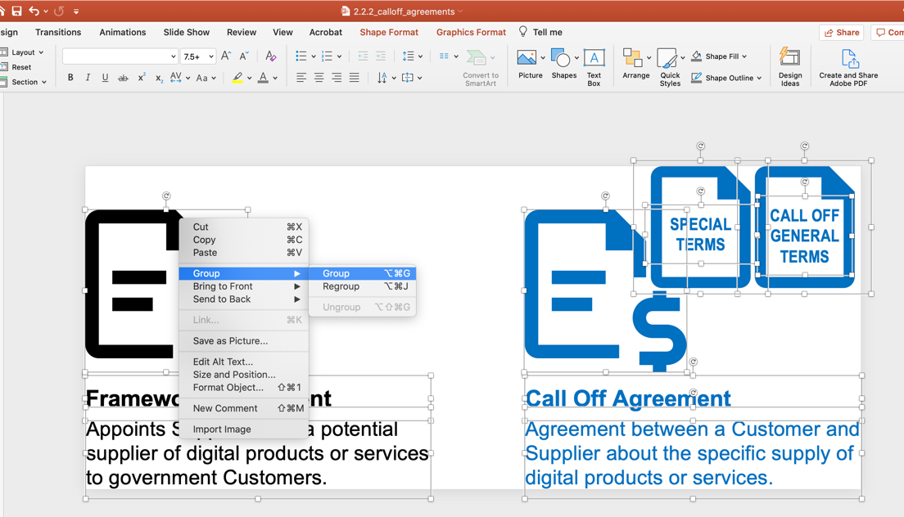

          - Go to the Word file. Delete the existing picture and left-click where the picture used to be, so as to indicate the location where you’ll place the new diagram.
          - Go back to PowerPoint. Select the grouped diagram and drag it from the PowerPoint file into the Word file.
          - Word will place the diagram over the text by default. In order to properly position it, right-click on the diagram in Word and then select “Wrap Text” > “In Line with Text.”
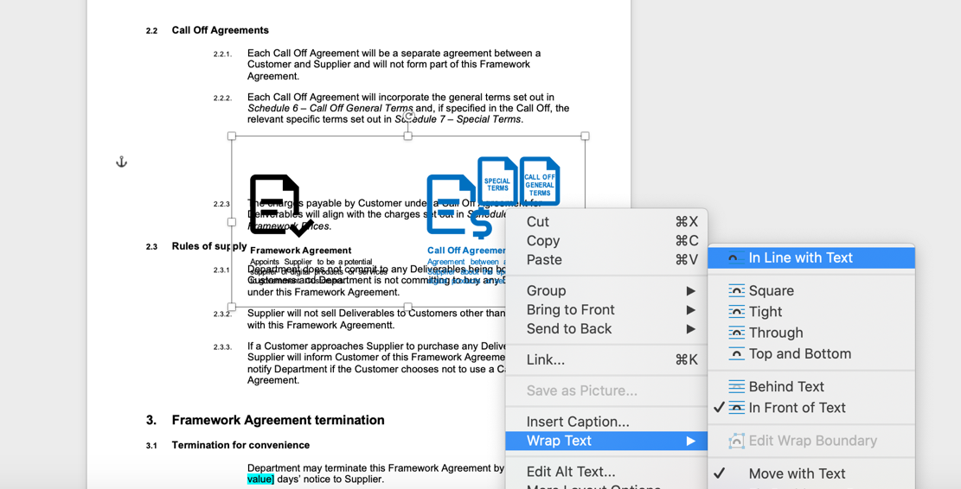

          - The image is now placed correctly.
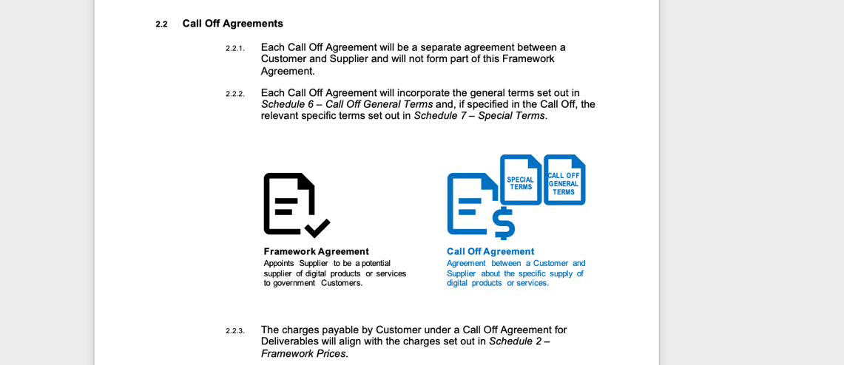

2. Word styles
This section illustrates, by way of example, how to use correctly the styles we set in Word for the Global Framework documents. The names in “quotes” refer to the names of the Word styles in use in the Global Framework documents. You can find all the styles by opening the Styles menu or the Styles Pane in Word (see image below).
Guidance on how to apply styles is available on Microsoft’s support pages.

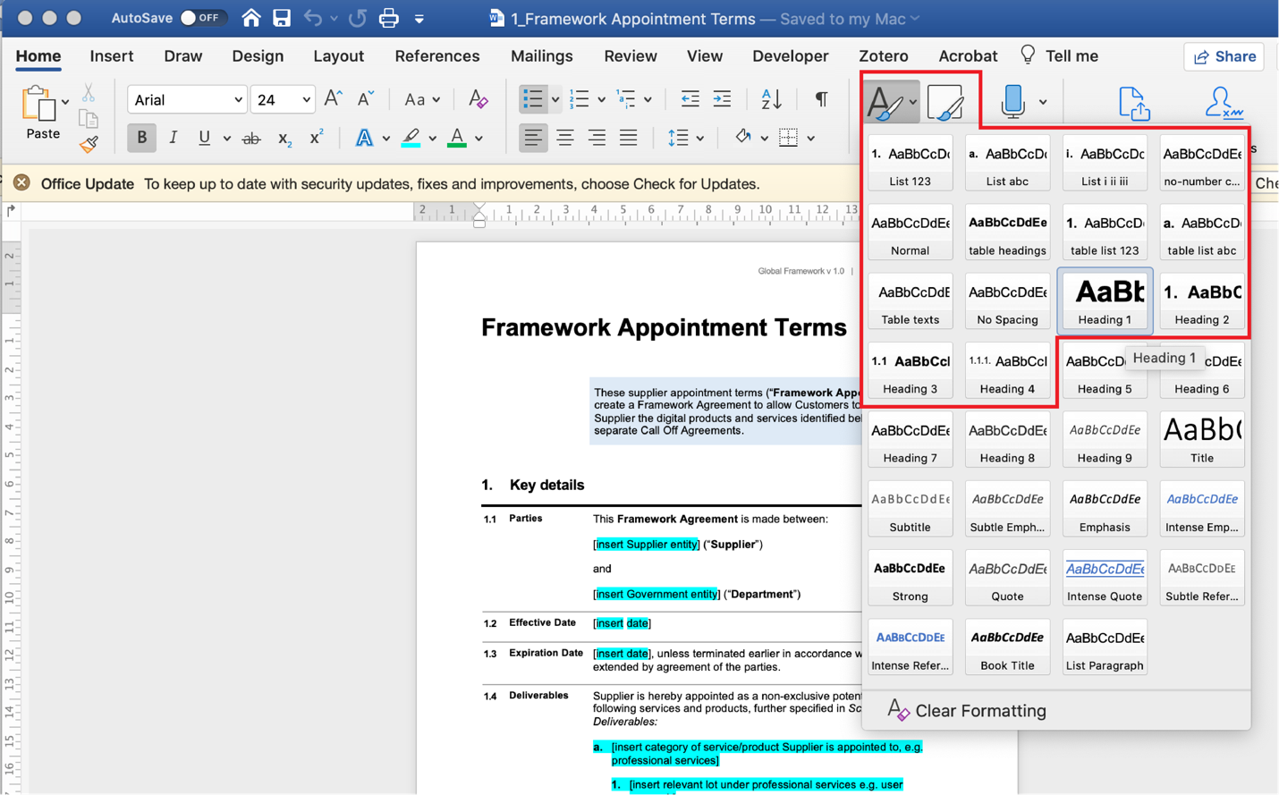

Use style “Part indicator” for the type of document (e.g., “Schedule x”)

Use style “Heading 1” for the name of the document (e.g., “Call Off Form”)
Light blue boxes are used to provide introductory information about a document. They are created with a single table cell, with background color set to # DEEAF6. Cell margins are set as top 0.3 cm, bottom 0.3 cm, left 0.19 cm and right 0.19 cm. The text is set in Word style “normal“ (Arial regular 11 pt, left-aligned).

1. Use style “Heading 2” for section heading

1.1 Use style “Heading 3” for sub-section heading

1.1.1 Use style “Heading 4” for numbered clauses.

1.1.2 Numbered clauses are used when there is more than one clause under a heading.

1.1.3 Lists under numbered clauses use the following styles:
a. The style named “List abc” is used for the first level of lists
        - If there is a nested list within a list…
          - … use the style named “List 123”
          - Should you need a third level of nested list items…
            - … use the style named “List i ii iii”.
            - However, we do not recommend using more than two levels of nested list items as it may make it too complex for the reader to interpret the clause. Try to draft clauses in a way to avoid complex nesting.

1.2 Use style “Heading 3” for sub-section heading
If there is just a single clause under a heading, use instead the style named “no-number clause texts”. This style looks like the text set in “Heading 4” style, but it lacks clause numbering, which is unnecessary if there aren’t several sub-clauses.

1.3 Use style “Heading 3” for sub-section heading
Single clauses set in style “no-number clause texts” can also be followed by lists
        - Also in this case, use the style “List abc” for the first level…
          - …style “List 123” for the second level…
            - … and style “List i ii iii” for the third level (although we do not recommend nesting lists for more than two levels)

2. Key details tables
Key details of an agreement (e.g. details in a Call Off Form) are displayed through 3-column tables.

2.1 Styles used in the tables
The text in the first column is set with style “Heading 3” so as to auto-number the items. No other text is added.
The text in the second column is set with style “table headings”.
The text in the third column is set with style “Table texts”.

2.2 Borders of the tables
The top and the bottom borders of the table are black, thickness 2 ¼ points.
The horizontal dividing border of the table are grey # A5A5A5, thickness ½ point.
There are no vertical borders, internally or externally.

2 | Style “table headings” | Style “table texts”  - Lists within a table use style “table list abc” for the first level of items…  - … and use style “table list 123” for the second level.
 | Style “table headings” | Style “table texts”
 | Style “table headings” | Style “table texts”

If a table header is needed, use font style “normal” (Arial bold 11 pt) and set a light grey background #F2F2F2
 | Style “table headings” | Style “table texts”
 | Style “table headings” | Style “table texts”
 | Style “table headings” | Style “table texts”

We are using capitalized terms to indicate the names of the documents that comprise the Global Framework (e.g. ‘Framework Appointment Agreement’, ‘Call Off General Terms’, or ‘Call Off Form’).
In this context, using the name “Call Off Form” would be misleading. We suggest changing the name of the document to e.g. “Agreement”.

